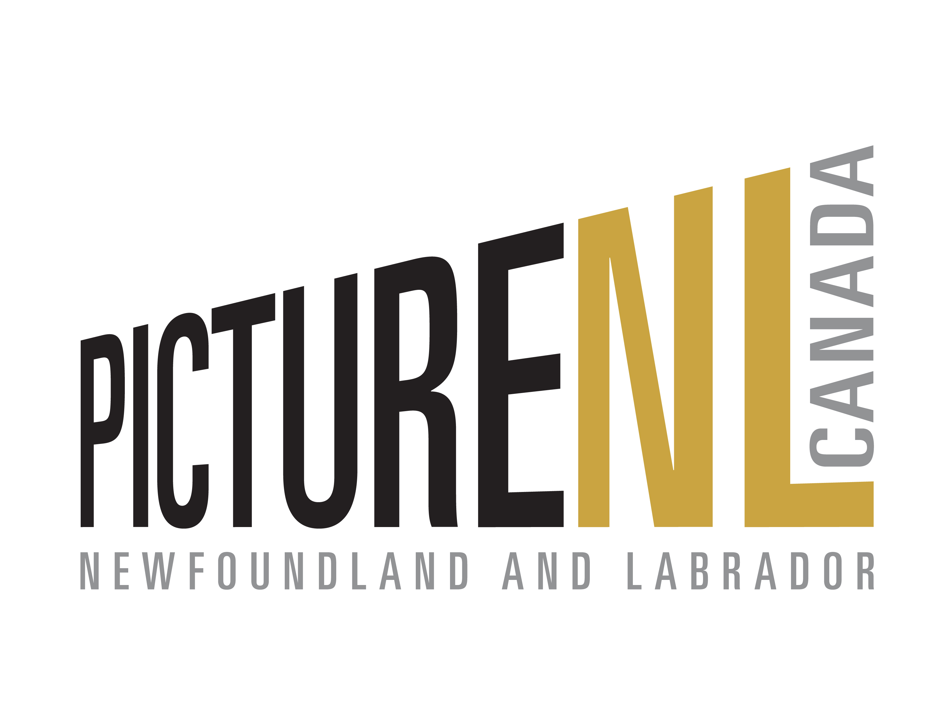

European Film Market Business Development Trip
February 13th – 19th 2025

Overview

PictureNL will hire a consultant for a business development mission to Berlin, Germany to take place during the European Film Market (EFM) from February 13th -19th, 2025 held during the Berlinale Film Festival. Seven producers from the four Atlantic Provinces, Newfoundland & Labrador (NL), Nova Scotia (NS) and Prince Edward Island (PEI) and New Brunswick (NB) will be selected to further enhance the promotion of coproduction, joint-financing, distribution and development opportunities between screen industry producers in the Atlantic Provinces and those internationally. The mission will enhance the group’s knowledge of working with producers on an international scale.

The following document outlines important dates and booking instructions for the Newfoundland & Labrador participants in this initiative.

Advance Preparation

To help ensure producers are prepared for the trip, PictureNL will engage the services of a consultant for on-the-ground consulting services while in Berlin. Selected applicants will be notified of the consultant once they are selected in early December.

Selected candidates will be contacted by the consultant shortly thereafter to begin initial virtual discovery sessions in advance of the mission.

Department of Tourism, Culture, Arts and Recreation (TCAR) Travel Assistance

To assist companies with the costs associated with this trip, participants are eligible for a travel stipend through the TCAR Business Investment Fund. Accepted candidates will receive more information on this process once selected.

Travel and Accommodations

Companies will be responsible for booking their own travel and accommodations for this trip. The delegation must be on the ground, for meetings in Berlin by the morning of February 13th, 2025 (subject to change).

Targeted Meetings

The Consultant will arrange a minimum of 5 targeted meetings for companies based on their individual needs. Where appropriate, group sessions may also be arranged. Selected attendees will be expected to share their travel itinerary with the Consultant and PictureNL in order to best accommodate their schedule. Selected attendees will be required to purchase a Market Badge for the EFM.

Application Process

In order to apply companies must complete the attached application form and provide supporting material by November 22nd, 2024. Below you will find the criteria for applications:

- Must have at least two producer credits on completed productions of the following nature:
  - Television one-off production with a minimum broadcast length of 30 minutes
  - Television series production
  - Feature film that a) received financing from a Federal and/or Provincial funding agency (NL, NS, PEI, NB) b) and a budget of $250,000 or greater
- Participated in at least one international market or festival event (can include provincially led business development trips/trade missions)
- Must have multiple viable projects for international markets

*If you feel you may not meet the criteria and are still interested in attending the mission, please contact Industry Development Manager, Jennifer Hawley.
Producer Application Form
European Film Market Business Development Trip
February 13-19th 2025
PictureNL Berlin EFM Mission 2025 | Producer Information Template – PLEASE FILL IN ALL SECTIONS
Name
Company Name
Email
Phone | Office: Mobile:
Website
Have you attended Berlinale/EFM before?
Company Short Bio

Project Title and Synopsis (one or two key projects suitable for Berlin)

Project Budget Total and Proposed Financing Structure.

Current Status (treatment, draft, pre-production)

Target Audience

Current Attachments | Creative: (director, writer, co-producer, stars) | Business: (development funding, distributor commitment, committed production financing)
Priorities for Meetings at Berlin EFM – please check all boxes that are of interest:
□ Canadian Co-Producers | □ Canadian Distributors | □ Canadian Financing Executives
□ International Producers (identify key territories of interest) | □ International Sales and Acquisitions Executives | □ International Financing Executives
Please identify territories of interest:
□ UK □ Scotland □ Ireland □ Germany □ Scandinavia □ France □ Spain/Portugal

□ Other (please identify)

Please identify other interests in attending the Berlin EFM not covered by above:

Applicants are invited to include any of the following additional package elements if available electronically as individual files:

- Project screenplay treatment and/or series bible.
- Completed screenplay
- Proposed principal cast
- Bios of any currently attached key creative positions
- Marketing and distribution plan and any existing marketing materials

________________________________________________________________
Signature Date

